Project Plan

Charity Events

Team: Thunderbirds

Lecturers: Simon Caton, Pavel Gladyshev, Deepak Ajwani.

Module: COMP47250 Team Software Project

Course: MSc. Computer Science Negotiated Learning

Date Due: 7th June 2021

Table of Contents

1. Project Objectives 1

2. Project Plan 1

3. Roles 2

4. Architecture 3

5. Data Plan 3

6. GitHub 4

7. Team Managment 4

**Project Objectives**

In recent years, many amateur clubs have started hosting various sports related competitions to raise funds for their clubs. Due to the current COVID crisis it has become very difficult for them to organise and run these competitions effectively.

The requirement is to help organise these competitions in a way that participants can enter remotely without having to be physically there. The main objective of this project is to develop a distributed system that will provide a web application for the participants to enter a desired competition. The participants should be able to enter the competitions via their mobile phone by sending text message or by logging into the website.

We hope to achieve this by creating a microservice which will be the front end of the web application providing UX. The back end microservice will deal with requests coming from the clients. Based on these requests, this service will allow organisers to create events and participants to register for these events. The communication between the front facing microservice and backend microservice will be achieved by using REST API over HTTP requests and responses. Some potential participants might not have access to the web application, so each service will implement a mechanism to accept text messages from a phone which contains the participants information and selection.

We plan to implement this using Azure Service Fabric which is a distributed system platform that will allow us to create and manage scalable and reliable microservices and containers. Finally, the UX microservice should allow administrators access and manage various data related to all the ongoing competitions.

**Project Plan**

**Roles**

|  |  |
| --- | --- |
| Andrew Bolt | Front-end Developer, UX Design, UI Design, User Testing, Team Lead. |
| Rakshanda Chavan | Front-end Developer, UX Design, UI Design, Back-end Developer, Cloud Database, Application Deployment. |
| Xinhao Chen | Back-end Developer, Software Testing, Application Deployment. |
| Shubham Narandekar | Back-end Developer, Cloud Database, Application Deployment, Software Architect. |
| Anurag Thoke | Front-end Developer, UX Design, UI Design, Back-end Developer, Cloud Database, Application Deployment, Scrum Master. |
| Shaoshu Zhu | Back-end Developer, Cloud Database, Application Deployment, Software Architect, Software Testing, User Test. |
| Nikola Zlokapa | Back-end Developer, Cloud Database, Software Architect. |

Front-end Developer – The front-end developer will ensure that the website visitors can easily interact with the page and implement the UX and UI Design.

UX Designer – Consists of developing and improving the quality of interaction between the user and the final product.

UI Design – Consists of designing all the visual and interactive elements of the product interface.

Back-end Developer – This will consist of a variety of things such as building microservices, building required API’s and the communication between microservices and mainly the all the functionality on the server side of the application.

Software Testing – Will be responsible for the quality of the software that will be deployed by performing automated and manual tests.

User Testing – Will be responsible for testing the UX and UI to make sure the product is very user friendly.

Cloud Database – This role will consist of designing the database and providing the communication between the microservices and the database.

Team Lead – The team lead will be our main spokesperson when communicating with mentors and lecturers while also making sure that the team functions smoothly together.

Scrum Master – The scrum master will be responsible for ensuring the team is following a true agile process throughout the entire project.

Application Deployment – This role will consist of things like creating docker images of the microservices and then deploying them into containers in a cloud environment which are managed by the Azure Kubernetes Service or if we are using Azure Service Fabric then, publishing the application into service fabric clusters.

**Architecture**

Front-end technologies include React, JavaScript, CSS, HTML

Back-end technologies include .NET, C#, Azure Kubernetes Service or Azure Service Fabric, Docker, Azure SQL, and MySQL (on local machine), Postman.

We have not been granted the credited accounts for Azure which will be our cloud environment and hope to have this set up after our next meeting with the Microsoft mentor. We have decided on our system architecture, and we will be using React for the front end, which includes JavaScript, HTML and CSS. For the back end we have opted for .NET framework in which we are going to use C# to create the backend microservice. Along with this, for the database we are going to use Azure SQL which is a relational database. For the communication purpose we are going to use REST API over HTTP requests and responses and for testing the APIs we will be using POSTMAN.

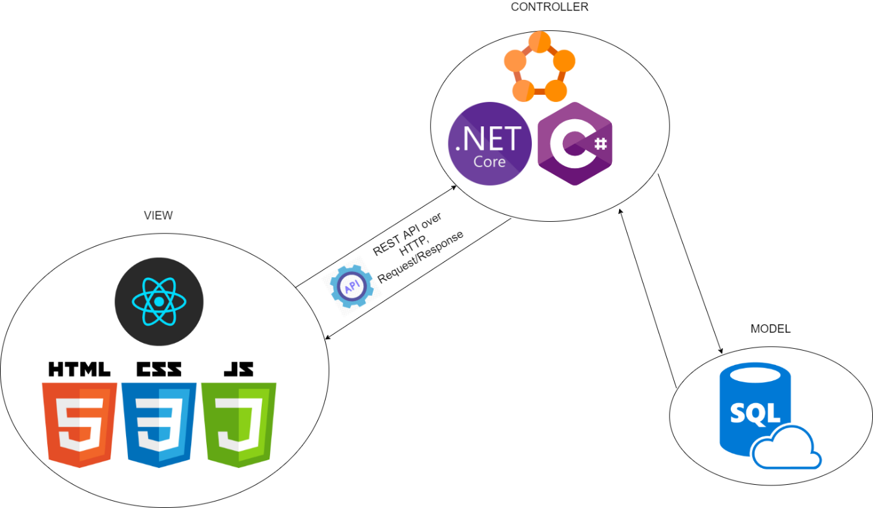

**Data Plan**

When considering our target audience, we found we would not be generating our own data. Both Organisers and participants will generate sign up user information such as name, email, age, phone number, etc... Additional information for credit card details will need to be supplied by participants so they can purchase tickets to events and organisers to receive payment for their events. Furthermore, the organisers will be responsible for generating event data such as venue, time, price, and anything else required to create an event.

**GitHub**

[GitHub Repository](https://github.com/ucd-nlmsc-teamproject/ThunderBirds)

All GitHub Activity can be viewed with the link above, it includes our minutes of meeting, our wireframe design, and the prototype design along with all other sections required for the project plan.

**Team Management**

[minutes of meetings](https://github.com/ucd-nlmsc-teamproject/ThunderBirds/tree/main/Meeting%20Minutes)

We have regular team meetings taking place and the minutes of these meetings are being recorded and can be seen by clicking the above link.

For our project we will be using Jira to record our sprints, assigned tasks and check in on progress where all members have been registered.

